# EDUCATION

## Bachelor In Technology

### Chandigarh University

*07/2018 - Present*, *Mohali, Punjab*

*Courses*

Computer Science And Engineering

**Intermediate(CBSE)**

Rainbow School

*04/2017 - 04/2018*, *Jaipur, Rajasthan* Achieved Overall 91.4%

Majored in Mathematics

**High School(CBSE)**

Rainbow School

*04/2015 - 04/2016*, *Jaipur, Rajasthan* Achieved Overall 9.4 CGPA

Majored In Science

**PERSONAL PROJECTS**

Annabelle Creations (05/2019 - 06/2019)

Hotel Management Website using HTML5, CSS3, JavaScript and PHP

DAVID CHU'S CHINA BISTRO (04/2020 - 05/2020)

**SKILLS**

Python

C++

HTML5

CSS3

JavaScript

Website Optimization

Interpersonal Communication

Project Planning and Development

Innovative

Cultural Awareness

**CERTIFICATES**

The Joy of Computing using Python (03/2020 - 04/2020)

*12 Week Course Oﬀered by IIT-Madras through Nptel, secured 94%*

HTML, CSS and JavaScript for Web Developers (05/2020 - 06/2020)

*5 Week Course Oﬀered by John Hopkins University through Coursera*

#### Computational Thinking for Problem Solving (05/2021 - 06/2021)

*4 Week Course Oﬀered by University of Pennsylvania through Coursera*

#### Machine Learning (06/2021 - Present)

*11 Week Course Oﬀered by Stanford University through Coursera*

# LANGUAGES

Online Restaurant and Food Ordering Website using HTML5, CSS3 and JavaScript

John - Voice Assistant (10/2020 - 11/2020)

Personal Virtual Assistant using Pyhton3

Sign Language Recognition (03/2021 - 05/2021)

American Sign Language Detector using tensor ﬂow, open CV and Convolutional Neural Network

English

*Full Professional Proﬁciency*

# INTERESTS

Business Research

Reading Books

Hindi

*Full Professional Proﬁciency*

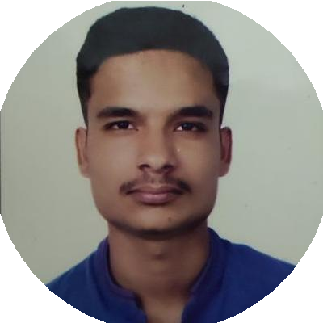

[instagram.com/a_r._i._n?utm_medium=copy_link](https://instagram.com/a_r._i._n?utm_medium=copy_link)

[github.com/Arin673](https://github.com/Arin673)

live:.cid.b8bd77a22deac55c

[twitter.com/Arin44048627](https://twitter.com/Arin44048627)

[linkedin.com/in/arin-kumar-a3ab5316b](https://www.linkedin.com/in/arin-kumar-a3ab5316b)

Jaipur, Rajasthan, India

6376913429

[arinkumar9724@gmail.com](mailto:arinkumar9724@gmail.com)

Arin Kumar

Front End Web Developer

Energetic graduate student eager to apply extensive knowledge of project coordination and completion to achieve company goals. Expert at leading and coordinating with others on web development(full- stack) projects throughout history of academic excellence. Dedicated to working until projects are completed and meeting highest standards. Driven to learn quickly, advance computer proﬁciency and training in industry operations. Solid background in ﬁeld and oﬃce settings supporting team needs.

Debate and Group Discussions

Barcelona and Messi Fan

Learning new sciences